Mã sinh viên: 20221007
Họ tên: Đinh Anh Tú

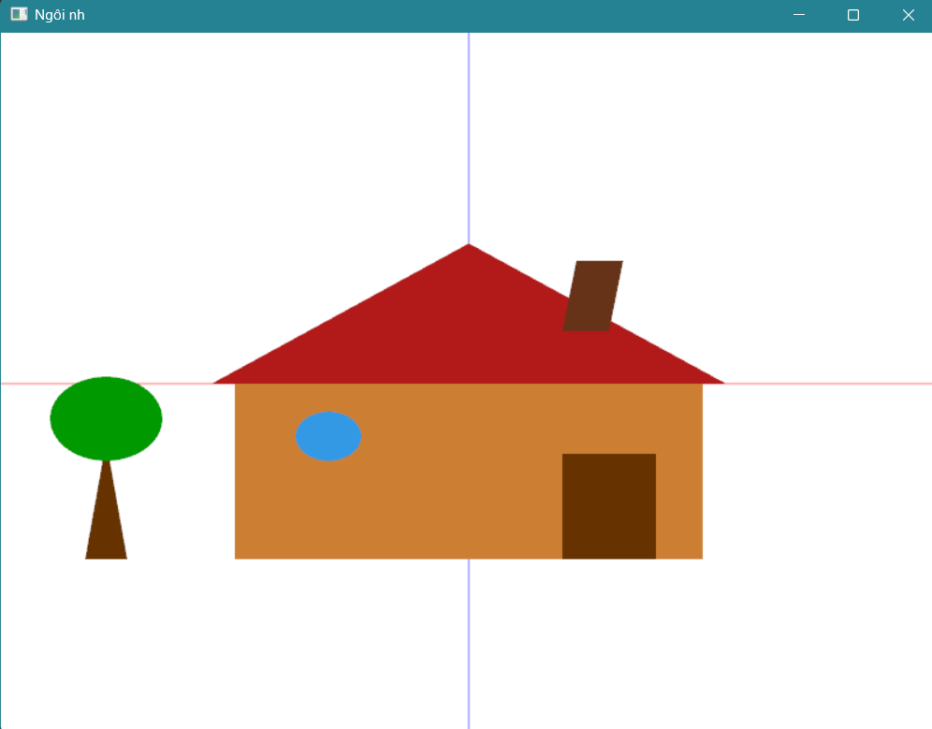

#include "glut.h"
#include <cmath>

const int WIDTH = 800;
const int HEIGHT = 600;

// Hàm vẽ hình tròn
void drawCircle(float cx, float cy, float r, int num_segments = 100) {
glBegin(GL_POLYGON);
for (int i = 0; i < num_segments; ++i) {
float theta = 2.0f * 3.1415926f * i / num_segments;
float x = r * cosf(theta);
float y = r * sinf(theta);
glVertex2f(x + cx, y + cy);
}
glEnd();
}

void display() {
glClear(GL_COLOR_BUFFER_BIT);

// Trục X
glColor3f(1.0f, 0.0f, 0.0f);
glBegin(GL_LINES);
glVertex2f(-1.0f, 0.0f); glVertex2f(1.0f, 0.0f);
glEnd();

// Trục Y
glColor3f(0.0f, 0.0f, 1.0f);
glBegin(GL_LINES);
glVertex2f(0.0f, -1.0f); glVertex2f(0.0f, 1.0f);
glEnd();

// Thân nhà
glColor3f(0.8f, 0.5f, 0.2f);
glBegin(GL_POLYGON);
glVertex2f(-0.5f, -0.5f);
glVertex2f(0.5f, -0.5f);
glVertex2f(0.5f, 0.0f);
glVertex2f(-0.5f, 0.0f);
glEnd();

// Mái nhà
glColor3f(0.7f, 0.1f, 0.1f);
glBegin(GL_TRIANGLES);
glVertex2f(-0.55f, 0.0f);
glVertex2f(0.55f, 0.0f);
glVertex2f(0.0f, 0.4f);
glEnd();

// ỐNG KHÓI
glColor3f(0.4f, 0.2f, 0.1f);
glBegin(GL_POLYGON);
glVertex2f(0.2f, 0.15f);
glVertex2f(0.3f, 0.15f);
glVertex2f(0.33f, 0.35f);
glVertex2f(0.23f, 0.35f);
glEnd();

// CỬA CHÍNH
glColor3f(0.4f, 0.2f, 0.0f);
glBegin(GL_POLYGON);
glVertex2f(0.2f, -0.5f);
glVertex2f(0.4f, -0.5f);
glVertex2f(0.4f, -0.2f);
glVertex2f(0.2f, -0.2f);
glEnd();

// CỬA SỔ
glColor3f(0.2f, 0.6f, 0.9f);
drawCircle(-0.3f, -0.15f, 0.07f);

// Thân cây
glColor3f(0.4f, 0.2f, 0.0f);
glBegin(GL_POLYGON);
glVertex2f(-0.82f, -0.5f);
glVertex2f(-0.73f, -0.5f);
glVertex2f(-0.77f, -0.2f);
glVertex2f(-0.78f, -0.2f);
glEnd();

// Tán lá
glColor3f(0.0f, 0.6f, 0.0f);
drawCircle(-0.775f, -0.1f, 0.12f);

glFlush();
}

void init() {
glClearColor(1.0, 1.0, 1.0, 1.0);
glMatrixMode(GL_PROJECTION);
glLoadIdentity();
gluOrtho2D(-1.0, 1.0, -1.0, 1.0);
}

int main(int argc, char** argv) {
glutInit(&argc, argv);
glutInitWindowSize(WIDTH, HEIGHT);
glutCreateWindow("Ngôi nhà");
glutDisplayFunc(display);
init();
glutMainLoop();
return 0;
}

